 [Working with the R&S SGS](helpmerge-hooknode.htm) > [Network and Remote Control Operation](27d1194ecdc4473c.htm) > [Starting a Remote Control Session](426433b4c2954972.htm) > Example: Remote Control over LAN Using VXI-11 Protocol

**Example: Remote Control over LAN Using VXI-11 Protocol**

In the following example, the program "Measurement & Automation Explorer" from National Instruments is used on a Windows operating system to set up a LAN remote control link and start a remote control session. The remote control program "Measurement & Automation Explorer" opens the connection to the instrument (using VISA functionality) and then sends commands to and receives device responses from the instrument.

A remote control connection requires a VISA installation but no additional hardware on the controller PC. The LAN I/O channel is selected at initialization time using the VISA resource string (also referred to as "address string"). A VISA alias (short name) is used to replace the complete resource string. The host address is either the R&S SGS's computer name or its IP address.

Proceed as described in ["Assigning the IP Address"](236ea45457964aba.htm#ID_d351edbcaa1b91310a710a31016b4f5a-3bf399e83b4b2d8f0a00206a0145c1f3-en-US) to determine the relevant address information.

_

|  |  |
| --- | --- |
|  | In this example, it is assumed that:   * A LAN remote control link between the controller and the R&S SGS is already set up. For information on setting up the link, see ["Connecting a Remote PC via LAN"](a43177f98dce49cc.htm#ID_bc389456aa1134bd0a00206a00458923-3bf399e83b4b2d8f0a00206a0145c1f3-en-US) * A VISA and the "Measurement & Automation Explorer" program are installed on the remote PC. For detailed information, refer to section "Remote Control Basic" in the user manual or to the online help of the "Measurement & Automation Explorer" program. |

_

**To configure the controller**

_

|  |  |
| --- | --- |
|  | The instrument is preconfigured for networks using DHCP (dynamic host configuration protocol). If this configuration is used, enter the computer name in the position of the IP address. |

_

To enable the external controller to communicate with the software via TCP/IP protocol, set up a remote control link as follows:

1. Connect the controller and the instrument to the network (network cable). Switch them on.
2. Start the 'Measurement & Automation Control' program on the controller.
3. Select "Devices and Interfaces > Create New".

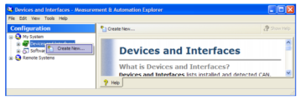

1. Select "VISA TCP/IP Resource" and confirm with "Next".

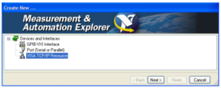

1. Choose the type of TCP/IP resource you wish to add and select "Next".

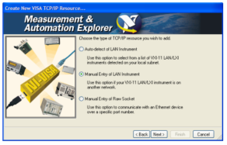

1. Enter the IP address or the host name of the R&S SGS and select "Next".
2. Enter the alias name if necessary.

The alias name should not be mistaken for the computer name. It is only used for instrument identification within the program and displayed in the menu as an option if there is an Ethernet link.

1. Confirm the settings with "Finish".

The instrument is configured and the settings are displayed in the "TCP/IP Settings" tab.

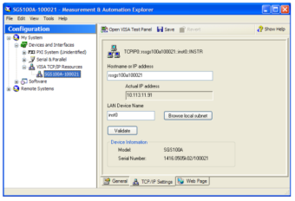

1. To test the connection, select "Validate".

A message indicates whether the link to the instrument can be set up or not.

If a connection cannot be set up, check whether the controller and the instrument are connected to the network (network cable) and switched on. Correct spelling of the IP address or the computer name can also be checked. For further error location, inform the network administrator. In large networks, specification of additional addresses may be required for link setup, e.g. gateway and subnet mask, which are known to the network administrator.

The instrument is now registered in the program and can be addressed via the resource string or alias name.

**To start a remote control session over LAN (using VXI-11)**

1. Start the "Measurement & Automation Explorer" on the controller.
2. In the "Configuration" window, select "Device and Interfaces > VISA TCP/IP Resources", select the required instrument and select "Open VISA Test Panel".

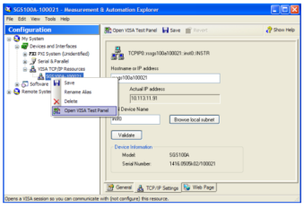

1. In the "viWrite" tab, write the command, which you want to send to the instrument. Select "Execute".

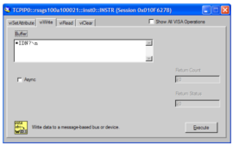

Instrument responses are displayed on the "viRead" tab.

**Tip:** For further program operation, refer to the online help of the program.